INI Configuration File

What is an INI Configuration File?
# Source: AI Source: Provided by: [Data Path: Persons Table -> ID Column: 1, Name_En Column: Motasem Essam] -> From: [ChatGPT] on [1/26/2026]
An INI configuration file is a simple, text-based file format used to store configuration settings in a structured but human-readable way.
- It is one of the oldest configuration file formats, commonly used in Windows applications and legacy software.
- INI files are section-based, meaning settings are grouped under named headers.

Key Characteristics
# Source: AI Source: Provided by: [Data Path: Persons Table -> ID Column: 1, Name_En Column: Motasem Essam] -> From: [ChatGPT] on [1/26/2026]
- Format:
  - Sections are defined with [section_name]
  - Key-value pairs inside sections are written as key = value
  - Comments start with ; or #
- File Extension: .ini
- Purpose:
  - Store application settings, environment info, and preferences
  - Easy to read and edit manually
  - No complex nesting (best for simple configs)

Example INI Configuration File
# Source: AI Source: Provided by: [Data Path: Persons Table -> ID Column: 1, Name_En Column: Motasem Essam] -> From: [ChatGPT] on [1/26/2026]
config.ini
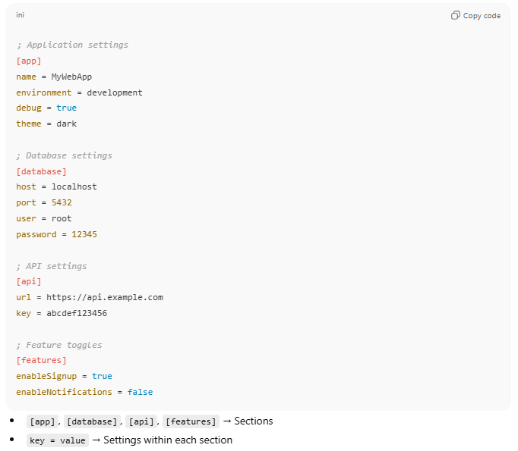
; Application settings
[app]
name = MyWebApp
environment = development
debug = true
theme = dark

; Database settings
[database]
host = localhost
port = 5432
user = root
password = 12345

; API settings
[api]
url = https://api.example.com
key = abcdef123456

; Feature toggles
[features]
enableSignup = true
enableNotifications = false
- [app], [database], [api], [features] → Sections
- key = value → Settings within each section

How to Use in Code
# Source: AI Source: Provided by: [Data Path: Persons Table -> ID Column: 1, Name_En Column: Motasem Essam] -> From: [ChatGPT] on [1/26/2026]
Python Example
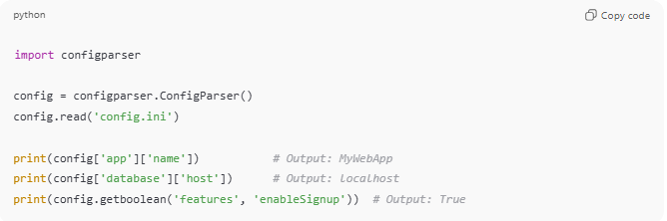
import configparser

config = configparser.ConfigParser()
config.read('config.ini')

print(config['app']['name']) # Output: MyWebApp
print(config['database']['host']) # Output: localhost
print(config.getboolean('features', 'enableSignup')) # Output: True
Node.js Example
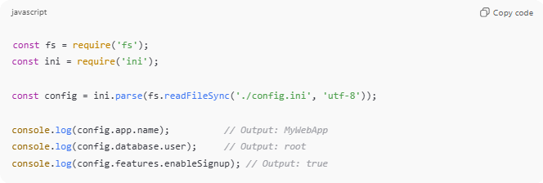
const fs = require('fs');
const ini = require('ini');

const config = ini.parse(fs.readFileSync('./config.ini', 'utf-8'));

console.log(config.app.name); // Output: MyWebApp
console.log(config.database.user); // Output: root
console.log(config.features.enableSignup); // Output: true

Advantages of INI Files
# Source: AI Source: Provided by: [Data Path: Persons Table -> ID Column: 1, Name_En Column: Motasem Essam] -> From: [ChatGPT] on [1/26/2026]
- ✅ Simple and easy to read
- ✅ Human-editable
- ✅ Supports sections for grouping
- ✅ Lightweight

Disadvantages
# Source: AI Source: Provided by: [Data Path: Persons Table -> ID Column: 1, Name_En Column: Motasem Essam] -> From: [ChatGPT] on [1/26/2026]
- ❌ No support for nested objects or arrays
- ❌ Limited to simple configurations
- ❌ Less popular in modern web development

💡 Analogy:
# Source: AI Source: Provided by: [Data Path: Persons Table -> ID Column: 1, Name_En Column: Motasem Essam] -> From: [ChatGPT] on [1/26/2026]
INI files are like a set of labeled drawers: each drawer (section) holds a few labeled items (key-value pairs). Easy to find and edit, but not suitable for very complex setups.

